

Matthew Capps

Computer Science

02 May 2019

**Abstract/Summary**

The main objectives of this project were to develop a working website for a local company based out of Longview Washington. The client is Gary and Angie Bishop and they wanted a website where their potential customers could visit and see the products, they offer throughout the year and what is currently in stock. Throughout the project I will be describing how and why I chose to design/develop each stage of the project. As with every project there is always unforeseen issues that arise throughout the process of completion. I will be describing what problems occurred throughout the project design/development.

**Introduction**

For this project I decided to develop and implement a website for the local company Lil’ Bitty Bishop Farm based out of Longview Washington. During this project I have encountered many problems throughout development. The first problem I encountered was communication between the client and myself. At the beginning communication was off and on about every other day while I was designing their website. But once the design phase was complete it was extremely hard to reach the client via email, text or phone call. During the past few months I would report for military training to the armory in Longview so I would stop by their house to check in to make sure they liked the design so far once I had most of it programmed. Another issue was the client gave me the wrong info on the products they offer and with poor communication already they waited until a couple of weeks ago to inform me that they gave me an outdated product list and they changed over half of the detailed info and they removed about 10 to 15 of the scents they used to offer. To fix this issue I deleted the old tables in the database and created new ones with the updated information.

During the development I realized the website did not need a database attached because the client at first want the customer to be able to order online and they could fulfil their orders. But about half way through development they contacted me to inform me they changed their minds and they wanted a more in person feel to the website. They want the customer to be able to contact them directly so they can have a more personal relationship with the customer. So, I had to remove the add cart method within the code and redesign the product page since they no longer wanted one attached to their web page. But the problem with this was the database was a requirement for the project, so I kept the code for the database to show to the class, but it is not attached to the final design.

The system is designed to work on any device such as laptop, desktop or any mobile devices. I put CSS rules so that the margins would automatically downsize or enlarge to make the margin fit to the width and height of the given device. I set the margin of all of the webpages developed to auto so they would automatically change to the max height and width of the device using the webpage. The system was designed to go live and have anyone be able to open it with in the class but, the client has not responded to my phone calls. I told the client they needed to pay for the Domain name so the website could be live but they have yet to respond so the webpage has not yet gone live so the class will not be able to see it on their own devices.

I chose this project because I wanted to develop a website for a local company. The client is my brother-in-law and I wanted to design and develop a website for his small business on the side. Gary and Angie Bishop both work third shift and swing shift. Gary is a police officer for Longview PD and Angie works for Kaiser Permanente in Longview. But in doing this I quickly realized that if you try to develop something for someone for free, they will have little to no interest in helping you or caring what the finished project will look like. Once I had all the webpages developed, I went over them all with the client, but they cared very little of the finished project and was shocked that they would have to pay for the Domain name. I told them it was only going to be on average about $30 a year and if they wanted to have the client eventually order online then it would be quite a bit more because they would have to pay for a secure server so theirs and the clients information was protected from hackers.

For the project I chose to work alone so I worked on every stage of the project to develop it on time before the final presentations on 08 May 2019. I developed the webpage in HTML with CSS rules to make the pictures and everything else fit and look visual pleasing to the client and owner of the company. I used CSS rules to make the margins automatically go to the max height and width of the device using the webpage. I used MySQL to create the database and PHP to attach it to the webpage. I was going to use JavaScript to set up a form base to have the customer be able to sign up for business letters, but the client didn’t think they were ready for that stage of development yet.

**Literature Review**

The small businesses in or round Olympia that have a website all have similar set ups with a homepage, about, product and contact page. I based the website I developed off these similar attributes. I looked over multiple similar websites to get a better idea on how I would set up and design the clients webpage. I looked at Bootstrap and Angular for helping me design and program the webpage, but I chose to free hand everything to help build my experience with web programming. After programming the webpage, I was glad I didn’t choose to use one of the programs to help code the website because I learned a lot more of HTML and CSS during this process.

**Design Methodology and Design**

For the functional requirements there is no inputs or outputs because the webpage does not have a add cat or view cart method. The owner didn’t think they were going to add any additional products to their roster so they didn’t want me to add a login so they could go in and manually add new products. They will only offer the products listed currently for quite awhile because they only work for the mall business on the side. It would be very easy to add the administrative aspect to the system if they ever wanted to be able to manually add new products as they become available.

The database requirements are very simple because the system doesn’t need a database attached to the webpage. I created the database to meet the project requirements, but I did not attach it to the actual webpage because the company has very few products they offer. So, I did not need to attach the database to the actual webpage. If I add an administrative aspect to the webpage then you would need a login so not everyone could login and add or change any of the products.

Communication, Network and Internet considerations haven’t had a huge impact on the design and implementation of the webpage. The only internet consideration I have taken was the margins on the different devices use. I took that into account and made it so the margins all would automatically change to meet the max height and width of the device so the images and information would not be distorted or not look appealing.

The system will be able to be easily be joined with almost any other system. I chose HTML, CSS, PHP, and MySQL because they are widely used and easily joined with other systems. Most systems use MySQL to join a database to their system anyways so it will super easy to join my webpage with a windows form or like system.

The human factors I took into great consideration because if the webpage doesn’t look appealing to the customer, they won’t care what the client has to offer. So, the way I designed the system so that it looks appealing to the customer as soon as they open the webpage. The top of the webpage stays the same when navigating through the website. I designed the webpage to be easy to use and have all the information to be easily seen by all customers. The products page layout is designed to be seen easily and have all the desired information be attached to each image. All the images are easily seen without having to enlarge them for clarity.

**Non-Functional Requirements**

The Non-Functional Requirements such as managerial and resources of my system have very minimal requirements because it is a very simple webpage design. The managerial aspect would be able to be easily added to the webpage. I could add a few methods to the webpage allowing the owner of the business to add products as they become available, but the client didn’t want that added to the webpage just yet. The client doesn’t have a ton of resources, so they only wanted a minimal webpage for their clients to view. The client only has a certain number of products they offer, and they have no plan to expand their products beyond what they currently offer. This is only a side business, so they only have a few hours everyday to run the business and fulfil local orders from their regular customers.

**Use Cases**

The use cases are very simple due to the minimal interaction with the actual webpage. The owners will have access to the database and be able to add new product as they develop them, but they did not want to have that access just yet. The customer will be able to view all the available products the company currently offers. It would be very easy to add a method to the design to enable the customer to be able to add products to a cart and be able to pay online and track their order. But the client didn’t want me to add the method to the system because at this time they want to be contacted directly for a more in person connection to the potential client.

**Physical System**

For the design and layout of the webpage, I designed it for easy navigation from page to page. The homepage is connected as are all the pages through a class named menu and a href within the code. When you click on any of the navigation bar hot links located on the top right of the webpage it will take you to the appropriate page associated with the hotlink. The customer will be able to view each page with little difficulty and be able to contact the owners for any product clarification and any questions they might have about any of the ingredients or products that are offered by the company.

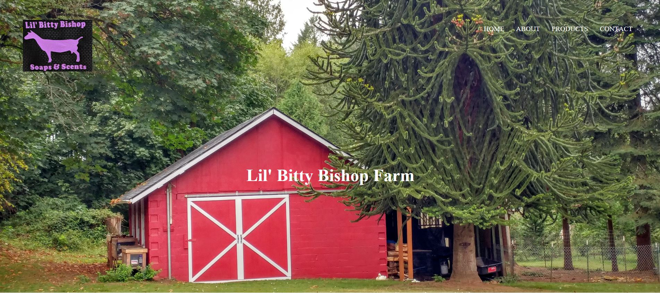

Above is the homepage with the navigation bar on the top right where the customer will be able to easily navigate throughout with little to no issues.

**Database**

The webpage I have developed will not work with a webpage, but the database can easily be added to the code and be able to pull from the database. If I would have made the database and attached it to the webpage, then I would have made a customer table where the customer would add their information in so they could be able to receive order updates as well as promotions that are offered by the company. Then there would be a product table, and it would have the descriptions and names of each product as well as what the product is available in. The product page would pull the information from the database tables and display it for the customer to view. If the client wanted the customer to be able to order online then there would have been an order table where the order id would be stored as well as what they ordered. It would be then attached to the customer and product tables by one to many because there can be multiple products and order ids associated with each client’s order.

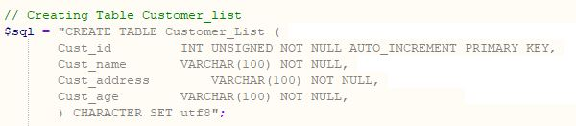

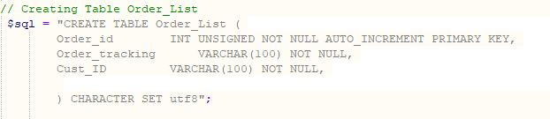

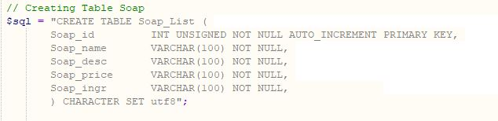

Above is the code for creating the Customer table as well as the other two tables (Soap and Order) I was going to create for the webpage before the client informed me of the change to the webpage.

The customer will not at this stage be able to interact with the database directly or indirectly. Since the client did not want to add the add cart method or attach a database to the webpage the client will not be able to interact with the database. If the database would have been added, then the customer would have been able to search the products for a certain one they want, and they would have been able to add items to the cart and be able to view the cart and order them. But the client didn’t want to have the add cart or search methods added to the webpage just yet because they are only in the begging stages of their small business and they don’t want to over extend themselves just yet since they are only working part time with their company.

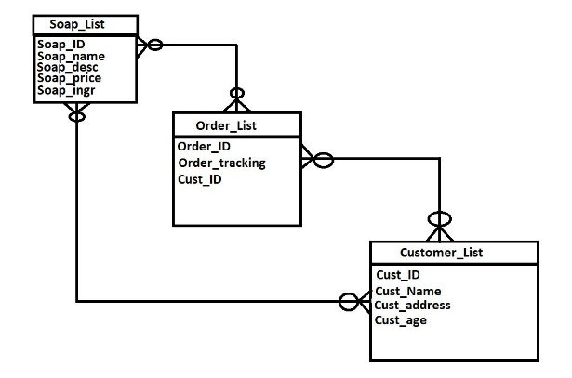

Above is the ERD for my database, I started to develop this system to accommodate orders and a way to track the order. But the client didn’t want to have a add cart method added to the website, so I had to change a few things around to fit the client’s needs.

**Implementation**

During the implementation of this system I chose to write the webpage in HTML, CSS, PHP, and MySQL. I chose these languages because they are so widely used and very easily able to be added to other systems languages such as C# and Java. The problems I encountered were mainly on the client side due to poor communication and the lack of interest of the client in the completion of the project.

For the test phase I would have liked to launch the webpage on the actual internet but the client has yet to get back to me with the fee for the Domain name. So, I could not test it on an actual internet connection. But throughout the entire process of development I would test each new line of code to make sure it worked properly and change anything that needed to be updated or changed. Due to this process I didn’t have any major issues throughout, but I learned to rely heavily on this method. By doing this I didn’t have to search hundreds lines of code to find errors that always occur throughout the developmental process.

**Completion Progression**

The first week of the course I contacted my brother in law to see if he would be interested in a webpage for his small business. It took a week or two to get a response about the potential client agreeing to the webpage, but he agreed and was excited to have a webpage for his company. Once he agreed we meet and came up with a design for the company’s website. After the design meeting I got to work on programming everything the client wanted and would check in with the client periodically to make sure they stall wanted the same design and if they wanted any changes. They sent me the product information eventually and I got to work on creating the database but after I was almost done creating the database the client contacted me to inform me they sent the wrong information about the current products and they would send me the new and updated list of products. After seeing the new product list, I realized the webpage did not need a database because the products they offered were so little and would easily be able to fit on one page without the aid of a database. After I completed each page, I met with the client a final time to get images for the webpage, but they only had a few and didn’t know when they would have the rest. Since they only had the images for the soaps, they offered I was unable to add the rest of the images for the rest of the products they offer such as bath bombs, body butter and room sprays. I tried the best I could to keep to the schedule I set but other courses and the client not giving me the correct data or communication, so I had to constantly adjust my schedule to complete the project on time.

**Experimental Result and Analysis**

To test the system there would not be much I could do because the system does not use a database or connect to a server. If the webpage was connected to the internet or the customer would have been able to order, then the webpage would have been connected to a secure server, but the client didn’t want to have that added to their webpage.

**Conclusion and Future Work**

During the beginning phases of the project I had high hopes of having a up and running webpage on the actual internet. But communication issues from the beginning it became clear to me that it would be highly unlikely I would have a fully completed webpage. After the course I plan on continuing to develop the webpage and getting the funds to get the webpage to go live and have an actual Domain name. After developing the project, I learned to work in a group because the work load gets crazy when your trying to balance work, school, military and a family. For future projects I plan on always finding other group members to help with the work load and for their input on the design and implementation phases of the project. For future projects I might investigate in using Bootstrap or Angular to help develop and program my future work to make it easier and more time efficient. But all in all, the project has been a huge learning curve for me because I thought I knew a good deal of HTML and other languages used but after this project I now know I’ve only scrapped the surface of each of these languages.